1. **Planning & Analysis**

* **User**: Professor
* **Purpose**: Help professors with class roll calls. Count daily attendance and make a chart of it.
* **Meeting schedule**: once week
* **Meeting notes**:

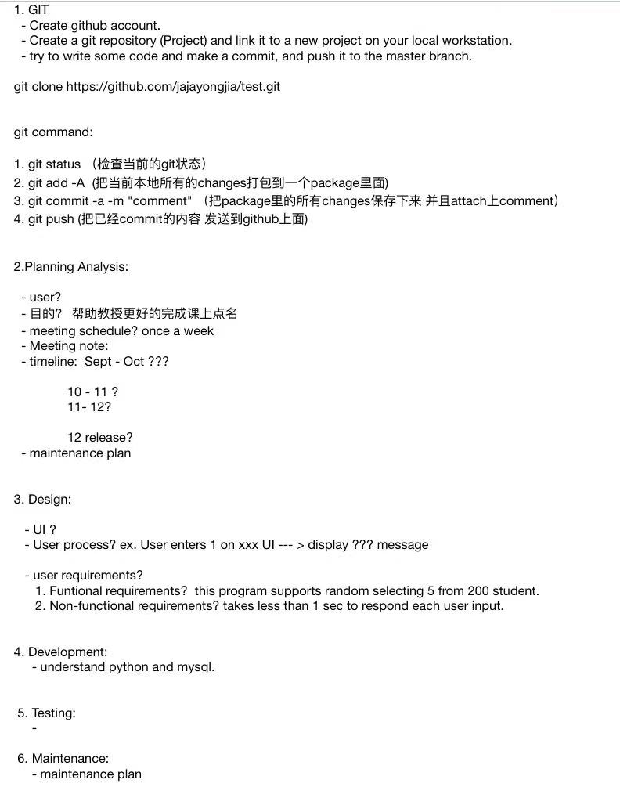Sep 9:

Sep 17:

* **TIme line**: September - October: Specify plans and designs, do development, including coding

October - November: Continue working on the development part

November: Finish coding, start testing and maintaining the project. At the end of November, release the project.

1. **Design:**

* UI: See https://github.com/HankWanggg/uni_project for details

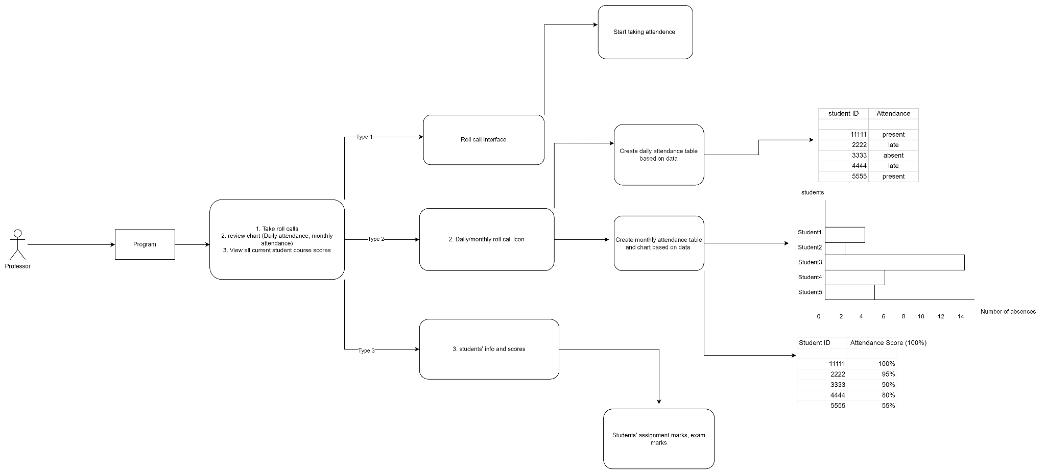

* **User process**: User type 1 enters the roll call interface and starts taking attendance. User type 2 enters the review chart interface, where the system randomly selects students to take attendance. Users can view students' daily/monthly attendance sheets and attendance scores. User type 3 enters the student results screen, where users can view student assignments and test scores.
* **User requirements**:

Functional requirements:

1. Professor needs to create his/her account, including username and password.
2. Professor needs to create course pages
3. Students need to create their account, including username and password
4. Professor needs to add existing students to the course page
5. This program supports randomly selecting 5 from 200 students.

Non-functional requirements:

1. The program takes less than one second to respond to each user input.